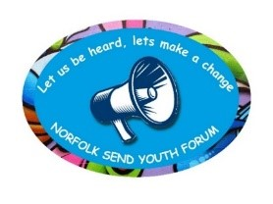
Norfolk SEND Youth Forum

Wednesday 17th April, 6:30 pm – 7:30pm

Meeting Agenda

- Introductions

- Flourish Pledge 2 (Dawn)

(Click on the link below to read more about this!)

https://www.norfolk.gov.uk/what-we-do-and-how-we-work/policy-performance-and-partnerships/partnerships/children-and-young-people-partnerships/children-and-young-people-strategic-alliance/the-flourish-pledge

- Visitor – Amy Driver, SEND Participation Officer at Norfolk County Council (NCC).

Amy would like your feedback on NCC SEND Strategy

- Visitor – Maxine Blocksidge, SEND Adviser at Norfolk County Council (NCC).

A return visit to provide us with an update on SENDFEST 24!!!

Any Other Business (AOB)

- FLOURISH awards – anyone interested in being part of a panel to judge the applications? Saturday in June @ County Hall date TBC
- SEND Fest – can sign up for one day/support on the stall or the other – ask for volunteers

